**Guided Solution for Tutorial 8**

1. Describe the 4 important building blocks of JPEG encoder.

The purpose of JPEG is for the compression and reconstruction of still photographic images.

The important building blocks of JPEG

1. Image/Block Preparation - xxx
2. Forward Discrete Fourier Transform - xxx
3. Quantization– xxx
4. Entropy Encoding - Zigzag – xxx

The decoder is the reverse process: Entropy decoder, reverse zigzag, dequantizer and inverse Discrete Fourier Transform.

1. Given a 3x3 grey-scale image given by the following matrix, f(x,y) denotes the intensity.

$$\begin{matrix}2 & 4 & 3 \\ 1 & 5 & 2 \\ 4 & 4 & 4\end{matrix}$$

Construct the Huffman codeword, average code length, source entropy and code efficiency.

The source symbols with occurrence are

s1=1, s2=2, s3=3, s4=4, s5 =1

Probability, Pi of the source symbols Si, i =1…5

P1 = 1/9, P2 = 3?, P3 = 1/9, P4 = ?, P5 = 1/9

Codeword

s4 1

s2 01

s5 001

s3 0000

s1 0001

(ii) Average code length  = ?

(iii) Source Entropy, 

H(x) = ?

1. Compute the Discrete Cosine Transform, DCT for one-dimensional array, m=[5, 4, 3, 2, 1] using the following formula.

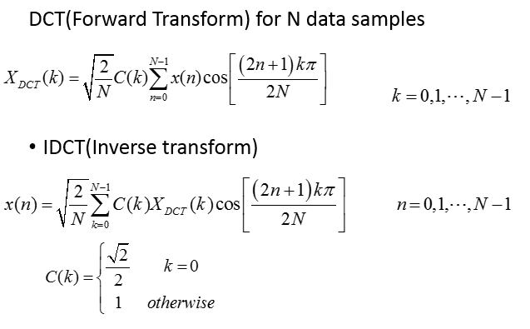

XDCT(0) = $\frac{1+2+3+4+5}{?}$ = ?

What will be DCT values both DC coefficient and AC coefficients, if m =[5, 5, 5, 5, 5] ? Why?

XDCT(0) = $\frac{5+5+5+5+5}{?}$ = ?